PhD INITIAL LITERATURE REVIEW

# Solid Electrolytes

## Ion transport in solids

The transport of ions in solids is a multiscale process, meaning it is built up by mechanisms acting over different scales. The overall level of conductivity in the solid is a function of all these mechanisms1. The smallest of these is the atomic scale, a level at which mibile cations diffuse along favourable migration pathways.

There are three main modes of ionic transport: the first on is the interstitial mechanism. This does not require any vacancies in the system, actually, it can proceed better without them being present. However, it does require the charge-carrying particles to be mobile and be able to move through interstitial sites exclusively. Charge-carriers must be small enough so that the energy barrier for moving between adjacent interstitial sites is possible even at room temperature.

The second main transport mode is the vacancy mechanism. This requires vacant sites in the lattice and so occurs when Frenkel or Schottky defects are favourable. When such defects are present, the charge carrier can “hop” between vacant sites, with a relatively low energy barrier. A similar mechanism is the divacancy mechanism, where vacant sites agglomerate to create divacancies. Then, diffusion can occur via these agglomerates of vacancies, which is like the vacancy mechanism but is described by slightly different equations. The divacancy mechanism is especially important at high temperatures.

The third transport mechanism is the interstitialcy or knock-on mechanism, which requires the charge carrier to be similar size to the atoms of the lattice in an interstitial site. A charge carrier in an interstitial site can displace one of the atoms of the matrix and move to a substitutional site, leading to the formation of a self-interstitial (an atom of the matrix in an interstitial site) and the movement of the charge carrier. However, the formation of the self-interstitial is not favourable.

A more complex diffusion mechanism derived from the ones already discussed is the interstitial-substitutional exchange mechanism. The requirements for this mechanism are that the diffusivity of the charge carrier is higher in the interstitial sites, but its solubility is higher in the substitutional site. In this mechanism, the charge carrier moves quickly between interstitial sites, before it moves back to the substitutional site, either by moving into a vacancy or by displacing an atom in the matrix (creating a self-interstitial)2.

The conductivity in solid materials is defined as the product of charge, concentration and mobility of charge carriers and is a thermally activated process, so can be described using an Arrhenius-type expression: $σ=q n u= σ_{0}T^{-1}e^{{-E}_{a}/k_{B}T}$. It is interesting to note that the best conductors on an atomic scale tend to be those materials with body centered cubic structures such as Li10GeP2S12 tend to be the best conductors. It was proposed that this property could be due to the availability of low-energy migration tetrahedral-tetrahedral hops3.

The next level up is microscopic scales. This level includes inhomogenities such as grain boundaries, which most often lead to a decrease in conductivity of the material. In fact, grain boundaries are often the bottleneck for low ionic conductivities in solid electrolytes. One study proposed that the reason for such a dramatic impact on conductivity was due to the “severe structural and chemical deviations to compensate for the random orientation of the adjacent grains”4. The result of these deviations is the formation of structures that are not energetically preferred for Li transport. Microscopic effects also include the contact between particles of the solid electrolyte and the particles of the electrodes. Good contact at this position is crucial for efficient ion transport and can once again limit the performance of the whole device.

Going another level up is the macroscopic scale, which is the first level where conductivity is being directly measured in experiments. This level is composed of a collection of different microscopic environments. Finally, at the device scale, which includes not just the electrolyte material but also the electrodes and the interactions between the two materials. It is at this level the optimisation of the electrolyte-electrode interactions are considered. For example, one study showed that the porosity of the electrodes and therefore the infiltration of electrolyte into the electrode plays a critical part in the conductivity of the device. It was shown that there are two effects in play, on being that the energy density decreases with higher porosity and the other relating to the need for porosity for increased conductivity5.

## Understanding battery terminology

It is important to understand the way batteries are classified. The name lithium batteries (LB) refers to any disposable device with lithium metal as the anode. Lithium ion battery is a term used to describe rechargeable devices where both electrodes are intercalation materials and the electrolyte is a lithium salt dissolved in some organic solvent. The name lithium microbattery indicates an all-solid-state thin film device (deposited via physical vapour depositition, PVD, or chemical vapour deposition, CVD) where the anode is lithium metal or an intercalation compound, the cathode is an intercalation compound and the electrolyte is a glassy or ceramic lithium ion conductor. Lithium polymer batteries and lithium air batteries are also interesting options to note, but do not bear much relevance to this review6.

## History of solid electrolytes

Liquid electrolyte batteries have been the focal point for research relating to energy storage for the past two centuries. These batteries have many advantages including high conductivity and excellent wetting of the electrode surfaces. However, they also have some drawbacks: poor electrochemical (electrolyte-electrolyte interactions) and thermal stability, concerns about aging effects and there have been safety issues relating to them7.

An alternative that has gathered increasing interest is the use of solid-state electrolytes. Solid-state ionic conductors are not a new sensation, as they date all the way back to the early 19th century. The earliest examples discovered by Faraday were Ag2S and PbF2, both of which appeared to be conductive when heated8. The first application for such solid-state materials was reported in the 1960s where the β-alumina was used as a conducting medium in electric generators, with mobilised sodium ions9. The technology was further improved in the 1980s, with the introduction of the ZEBRA batteries. These batteries were the first breakthrough in making safe and corrosion-resistant batteries for commercial uses. The high energy density these batteries had allowed for energy-intensive applications, such as batteries for electric cars10. Initially ZEBRA-type batteries were limited to use in applications where high operating temperatures of around 250C were tolerable.

With progress in the field, solid-state batteries operating at ambient temperatures were developed based on lithium-ion transport. These first utilised the organic polymers, such as poly(ethylene) oxide11, but later worked their way into inorganic solids. One of the ambassadors of the ambient temperature solid-state electrolytes were lithium phosphorus oxynitride (LiPON) thin films, which had good conductivities, but had issues with keeping a good contact with the electrodes12. The field of solid-state lithium ion batteries operating at ambient temperature is now growing rapidly starting with the discovery of much more efficient electrolyte materials, such as the perovskite-structured lithium lanthanum titanate, which has very high conductivity and has a better contact with the electrodes13.

By 2011, sulfide-based solid electrolytes including Li10GeP2S12 and Li2S-P2S5 were reported to have up to 5.2 x 10-3 S cm-1 lithium-ion conductivity at room temperature. This value is as high as that for conventional organic liquid electrolytes14. Thus, solid-state electrolytes are a promising alternative to liquid electrolytes, with added safety benefits and potentially increased lifetime. The importance of the field is also illustrated by decorated scientists, such as Nobel Prize winner John B. Goodenough contributing to the ongoing research15.

## Electrochemistry of solid electrolytes

While it is the electrodes that determine the energy density and cyclability of batteries, the electrolyte still has great effect on the overall performance of the device. It determines the power density and safety of the device6. Of course, a vital characteristic for the efficient operation of solid electrolytes is a high conductivity (>10-4 S cm-1 or better >10-3 S cm-1)16. However, there are other properties that need to be considered and improved for optimal performance. A wide electrochemical stability window (voltage range that it can sustain without redox composition, needs to be wide to make sure both electron and cation is mobile), high electronic area-specific resistance (electronic conductivity of <10-12 S cm-1) high ionic selectivity and good chemical compatibility with other components are just a few to be mentioned7. If all these properties are optimal the resulting voltage profile across the electrolyte looks as shown below, with an interphase of finite thickness forming, that is stable to further electrochemical decomposition and so provides a long lifetime.

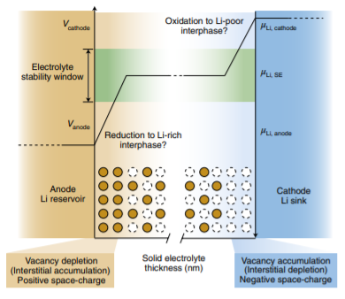

There are three types functional interfaces that can stabilise solid-state batteries in this manner. The first one is the functional interfaces are intrinsically stabilised and there is no reactivity between the electrolyte and the electrode. The second type is stabilised by kinetic stabilisation. Here, a thin layer of the electrolyte near the electrode decomposes and forms an electrochemically stable, ionically conductive layer that effectively screens the electrolyte from the electrodes, hence limiting any further decomposition while allowing battery functionality. The third possibility is artificial protection, where the interface is coated with a layer that modifies the effective stability window and smooths the voltage drop so that electrochemical reactions are less likely to occur.1

## Advantages and disadvantages of solid electrolytes

As mentioned before, perhaps the biggest advantage of solid-state electrolytes over their liquid-based equivalent is their enhanced safety. This chiefly stems from the elimination of the flammable liquid from the battery.

Another advantage is their compatibility with Li metal anodes. Liquid electrolytes are incompatible, as using Li anodes in them leads to the formation of dendrites at the electrode surface, reducing cyclability greatly. One of the greatest goals in the development of solid-state electrolytes is the commercial production of batteries with a Li metal anode replacing the traditional graphite anode, a solid-state electrolyte replacing the liquid electrolyte, with the cathode remaining the conventional intercalation cathode. Li anode with liquid electrolyte leads to dendrite formation and short-circuiting. This effect is considerably reduced with the use of solid electrolytes, although it has recently been shown that the strings of Li metal can in fact penetrate solid electrolytes, too17. Changing the anode would lead to an increase in energy density of the battery of more than 20%18. If such battery could be produced relatively cheaply, they would be prime candidates to be used in electric vehicles19.

The third major advantage of solid-state electrolytes is their wide range of operating temperatures. They can operate at temperatures where liquid electrolytes would boil or freeze, furthermore, their conductivity varies very little with temperature due to the low activation energy for ion migration. While this is true in most cases, it is important to note that there are some solid electrolytes whose performance significantly decreases at lower temperatures19.

The final advantage worth mentioning comes from the fact that the interfaces between the solid electrolyte and the cathode is not dynamic. Thus, the transition metals in the cathode do not significantly dissolve. This means more cycles are possible as the capacity decreases more slowly. Unfortunately, solid-state electrolytes were found to have ageing mechanisms of their own. There are issues relating to the composition of the material being different on the surface than it is in the bulk and the issue of keeping a good physical contact at the interface despite the stress developed on electrochemical cycling causing cracking20 and delamination21. The resistance of materials to delaminate is described by surface adhesion, an example of electrochemical coupling. Electromechanical coupling has contributions from the chemical interfacial energy (difference between interactions at surface and bulk), mechanical strain (lattice misfit between phases) and electrochemical attraction (charge reorganisation). During electrochemical reactions near the electrodes, electrochemical strain develops as the electrode undergoes cyclic expansion and contraction, which reduces the surface adhesion and can have detrimental consequences to the operation of the entire device.

Indeed, there are arguments that the minimalization of such interfacial impedances is the key to the mass production of all-solid-state batteries, rather than the maximisation of conductivity22. This argument is based on the idea that all-solid-state batteries with reasonable energy density will be so thin that conductivity will be rarely limiting. It has also been argued that other than chemical, electrochemical and mechanical problems that causes problems at interfaces, there is also a more fundamental issue relating to the “differences in the way that solids and liquids screen the electric field at interfaces”. There has been work published about a low-capacity but high-cyclical solid-state microbattery based on Li|LiPON|LiNi0.5Mn1.5O423, highlighting that there are in fact two main limiting factors for the development of all-solid-state batteries.

## Production of all-solid-state batteries

The more traditional methods of synthesis of solid electrolytes can either take place via dry mixing or wet processing of reagents in a solvent. Dry mixing requires higher temperatures, which could lead to unwanted reactions, but wet processing raises issues considering solvent recycling and waste production. There is also another approach involving mechanochemical synthesis, which can operate at low temperatures and require no solvent. However, this method appears to be problematic for scale up in terms of energy consumption and safety.

Once the electrolyte is synthesised, it needs to be densified to minimise ohmic resistance. This can be done via sintering and hot or cold pressing. Once densified, the solid electrolyte needs to be integrated with the electrodes and the other components of the battery. The most popular methods for this are thin-film methods, which can achieve great solid-solid contact.1

# Anti-perovskite Solid Electrolytes

## The anti-perovskite structure

Perovskite structures have general formula A2+B4+X2-3 are comprised of a primitive cell of A with X occupying the faces and B in the centre of the unit cell inside the X octahedron. Alternatively, it can be looked at as a primitive cell of B with X on the edges and A in the centre of the unit cell. This arrangement of B occupying the octahedra is rather than A is favourable, as this allows the higher charge of B to be balanced by the surrounding anions. The structure belongs to space group 221 (Pm-3m)24.

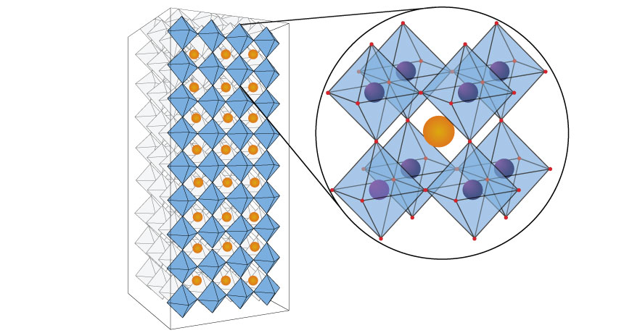

Figure 1. Perovskite structure25

Anti-perovskite structures are like perovskites, but the charge of the species is different. They have basic formula of A-B2-X+3 with B occupying the X octahedra. An example of this structure is Li3OCl with O in the Li octahedra and Cl in the 12-coordinated position.

## Lithium Anti-perovskites Solid Electrolytes

Li-rich anti-perovskite materials, such as Li3OCl, are a promising group of materials to provide solid electrolytes. These structures have all the required properties to be good solid electrolytes, including high ionic conductivity (low energy barriers for Li migration), low electronic conductivity (large band gap), wide electrochemical windows (stable operation), good cyclability and cheap production. Furthermore, they have the advantage of being easily modified, so that ionic conductivity can be optimised with ease26. This latest property is due to the structure being prone to iso- and aliovalent substitutions27.

They have initially been reported with very high conductivities (>10-3 S cm-1)28, but this value has been shown to be higher than what most subsequent studies found (10-6 S cm-1)29. This was proposed to be due to the presence of grain boundaries. These grain boundaries are generally common in Li3OCl, as the ions have relatively low charges and so there is a low energy penalty for cleaving ionic interactions. It is also interesting to note that Σ3 type boundaries tend to be lower in energy than Σ5 types, likely due to the higher disruption in the coordination environments for the latter30.

In case of Li3OCl and most anti-perovskite structures, the grain boundaries are more resistive than the bulk grains, so the mobile ion takes the granular pathway rather than the grain boundary pathway. When a mobile ion moves into a grain boundary it becomes effectively trapped in the grain boundary, until it eventually escapes, when it approaches the grain with the right orientation. Hence, the abundance of grain boundaries restricts the mobility of the Li/Na ions and is likely to be responsible for the reduced conductivity30.

Debate on the ion migration mechanism for anti-perovskite structure is ongoing. One of the earlier studies on the charge transport suggest that the concentration of Schottky defects capable of mediating transport in Li3OCl is low. They argue that the structure is metastable relative to decomposition to Li2O and LiCl, which means partial Schottky defects are low in concentration. Their calculations showed that the source of the high conductivity is Frenkel defects, where the interstitial Li form a dumbbell interstitial (split interstitial), while also leaving a vacant site. While Frenkel type defects are also quite high in energy, it was proposed that excess interstitial Li ions and/or vacancies are introduced during synthesis resulting in slight deviations from ideal Li3OCl stoichiometry. Then Li migration can either proceed via the vacancy or alternatively via a coordinated three-atom move involving the dumbbell interstitial. The latter method was calculated to have about half the activation energy of the former and it was proposed that this is responsible for the unexpectedly high conductivity31.

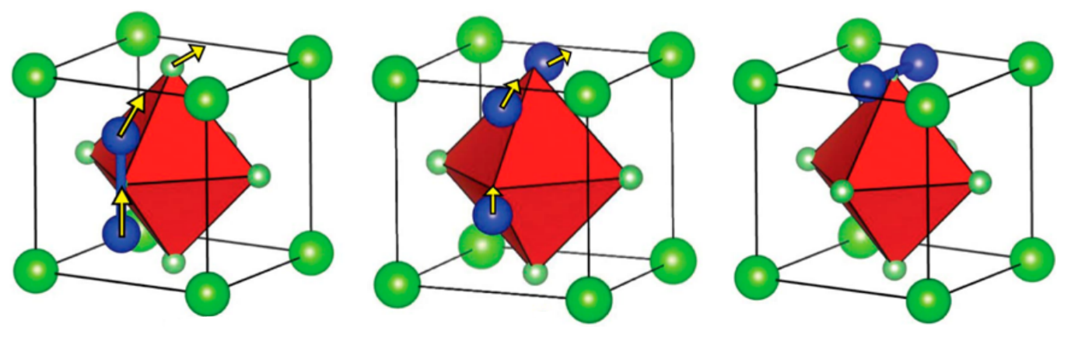

Figure 2. Migration of the dumbbell interstitial31

However, a later study proposed that the main transport mechanism in anti-perovskites is Li/Na vacancy hopping rather than interstitial diffusion. They argue that Schottky vacancy defects are the dominant type of intrinsic disorder, meaning the interstitial concentration is low26. More specifically, it was also proposed that the Li vacancies used for charge transport are compensated for by Cl vacancies as this partial Schottky defect is lower in energy29.

Unfortunately, it was reported that preparation from dry Li2O and LiCl is problematic and energy consuming as the reaction requires high temperatures, because of the metastable nature of Li3OCl anti-perovskite32. It was found that hydrated versions of the structure to make Li3-xOHxCl improves conductivity, while being easier to produce, too. Hydration is exothermic (-0.74 eV33), making the reaction favourable. The conductivities of these species are highly dependent on preparation and so it is important to find the best preparation mode. The hydrated form takes the anti-perovskite structure at temperatures over 300K allowing for higher ionic mobility by allowing OH- rotation. The presence of OH- rotation allows for the proton to move, allowing for easier Li hopping.

## Sodium anti-perovskite solid electrolytes

Sodium batteries with sodium solid electrolytes are an attractive option for large-scale energy storage, where energy density is not a necessity. They are relatively cheap to produce due to the high abundancy of sodium.

It was proposed based on computational studies that the partial Schottky defect responsible for the high conductivity of Na3OCl is NaCl26, while neutron diffraction studies on Na3OBr it is the Na2O defect34. However, with the current structure, the conductivity is too low for practical applications. It was proposed that doping and the use of larger anions in the octahedral site to increase lattice volume and so make the path for Na diffusion more accessible35.

Due to the soft nature of sodium anti-perovskites, the best route of synthesis is the mechanochemical route. Here equimolar mixtures of Na2O and NaX undergo high energy ball-milling. This is one-step process and there is no need for annealing35.

# Computer Modelling

## Interatomic Potentials

The atomistic potential model uses empirical equations to model solid-state lattice by simulating interactions between charged ions of the lattice. It is also able to repeat the unit cell in all directions by applying periodic boundary conditions. While both the empirical equations and the periodic boundary conditions are approximations, they provide an excellent mean to run cheap calculations on lattices, which is ideal for defect calculations36.

The model uses the system’s coordinates for calculations, described by the following equation for two- and three-body systems:

$$U_{L}=\sum_{ij}{V_{ij}\left(r_{ij}\right)}+\sum_{ijk}{V_{ijk}\left(r_{ijk}\right)}+…$$

These terms are comprised of long- and short-range interactions that are modelled by the Born model and interatomic potentials, respectively.

$$F=\frac{q_{i}q_{j}}{4πε_{0}r_{ij}}$$

In the Born equation above, the electrostatic force between two bodies is directly proportional to the charge of the species and inversely proportional to the distance between the species. It is also inversely proportional to the permittivity, signified by ε0. These coulombic interactions can account for as high as 90% of the total lattice energy in ionic materials37.

The equation above describes the Buckingham potential, one of the most popular interatomic potentials used to model the short-range interactions. A, ρ and C are parameters unique to every species. The positive term represents the repulsive forces of the electronic charge cloud of ions, while the negative models the attractive term. Interatomic potentials are most easily derived by empirical fitting to experimental data, involving the minimisation of the sum of squares.

While the two potentials discussed describe rigid lattices well, most lattices polarisation of ions is of great importance and needs to be accounted for. A popular way to account for this polarisation is to apply Dick and Overhauser’s Shell Model38. This method involves the division of each ion in the lattice into a core and a shell separated by coulombic forces. The core represents the nucleus of the ion and the core electrons and hence it is non-polarisable and is estimated to account for the entire mass of the ion. The shell is comprised of the valence electrons. so so it is polarisable and is estimated to have zero mass. The core and the shell have different charges, but the overall charge of the core-shell complex is equal to that of the ion. While the core and shell are screened by coulombic forces, they are linked via a harmonic spring, whose spring constant must also be input.

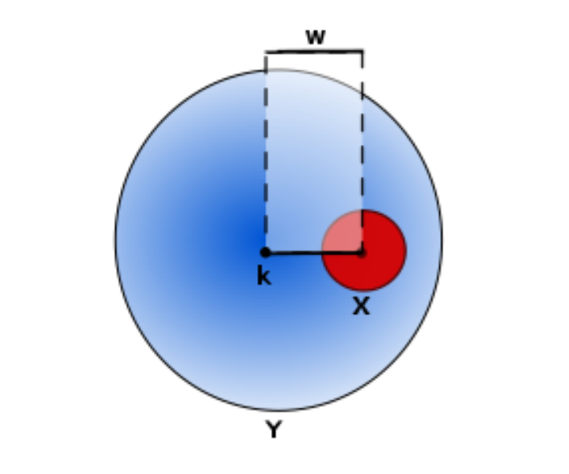

Figure 3. In the shell model the core and the shell have charge X and Y, respectively. The two are displaced by distance W, but connected by a harmonic spring whose spring constant is k.37

## Energy Minimisation

## There are a range of methods for energy minimization in computational chemistry. The best methods use are ones that investigate the first derivative of the potential energy function in terms of the atomic coordinates. These methods can find stationary points on the potential energy surface: minima and saddle-points. To differentiate between these two points the second derivative must be found. For a minimum, all second derivative must be positive.

## One method taking advantage of the derivatives of the potential energy function is the steepest descent algorithm. Here, the atomic coordinates are changed in a way that leads to the steepest gradient, meaning the largest decrease in energy. The direction in which the atomic coordinates are moved is described by the gradient unit vector (ri) which points in opposite direction to the gradient vector. Then, the distance to be moved can be determined by either a step of an arbitrary length or a line search, though the arbitrary step method is preferred. This method moves the atoms by an arbitrary length (αi) along the gradient unit vector. The method eventually converges on a minimum through a series of orthogonal successive steps. While this method is convenient for finding minima far from the initial starting point, it is not considered efficient.

$$xi+1 = xi + αir1$$

## An improvement over the steepest descent method is the conjugate gradient method. This algorithm uses a set of orthogonal vectors pointing in each dimension and only minimises the energy once. Then, the minimum is found by minimising the energy with respect to each dimension and combining these to get a search vector (di). Using this method has the advantage of being quicker than the steepest descent approach.

$$xi+1 = xi + αidi$$

## The third method is the Newton-Rapson method. This is a more complex method, where each new iteration is calculated by taking the atomic coordinates of the current configuration and subtracting the corresponding gradient for that point multiplied by the reciprocal of the Hessian matrix.

$$xi+1=xi Hi-1gi$$

While the Newton-Raphson method is great at finding minima rapidly, it is less useful for finding minima that are far from the starting point. This is because the model relies on the potential energy surface being harmonic or near harmonic, which is true for potential wells, but not for the surface in general. If there is no reliable experimental data available, a combination of steepest descent or conjugate gradient and Newton-Raphson method is often applied.

## Periodic Boundary Conditions

Solid lattices are theoretically infinite in all directions, meaning these systems are large. Modelling all of these atoms would be really expensive. Periodic boundary conditions allow this computational cost to be reduced greatly. This takes advantage of the regular patterns of solid lattices and the repetitive unit cells. In a calculation, a unit cell is modelled as being surrounded by other identical unit cells in all directions. Ions in the unit cell being investigated can interact with all surrounding ions, but ions in the surrounding unit cells may only interact with ions in the unit cell being investigated. Then, the energy of the unit cell can be calculated and scaled up to yield lattice energies.

## Defect Modelling

When a defect is added to a system, the whole lattice will slightly change, especially the ions nearest to the defect. Therefore, it is important to include some additional relaxation effect, primarily long-range ones. The Mott-Littleton approximation is used for this purpose. This model accounts for the loss of symmetry by splitting the lattice into two regions.

The region nearest the defect (Region I) include the defect and the ions surrounding it. This region of the lattice is relaxed explicitly to account for the great degree of disorder and includes both Buckingham potentials and coulombic forces. The outer region (Region II) then covers the rest of the lattice extending to infinity and is further divided into sub-regions IIa and IIb. In Region IIa, the ions in the lattice relax as a result of the ions in Region I relaxing and thus this region is modelled as a result of the central charge defect with coulombic forces exclusively. In Region IIb, the defect is only felt in a dielectric manner and so there is no actual displacement of ions, only a change in polarisation39.

1. T. Famprikis, P. Canepa, J. A. Dawson, M. S. Islam and C. Masquelier, *Nature Materials*, 2019, **18**, 1278-1291.

2. H. Mehrer, *Diffusion in Solids*, Springer, Berlin, 2007.

3. Y. Wang, W. D. Richards, S. P. Ong, L. J. Miara, J. C. Kim, Y. F. Mo and G. Ceder, *Nature Materials*, 2015, **14**, 1026-+.

4. C. Ma, K. Chen, C. D. Liang, C. W. Nan, R. Ishikawa, K. More and M. F. Chi, *Energy & Environmental Science*, 2014, **7**, 1638-1642.

5. A. Bielefeld, D. A. Weber and J. Janek, *Journal of Physical Chemistry C*, 2019, **123**, 1626-1634.

6. E. Quartarone and P. Mustarelli, *Chemistry Society Reviews*, 2010, **40**, 2525-2540.

7. A. Manthiram, X. W. Yu and S. F. Wang, *Nature Reviews Materials*, 2017, **2**, 16.

8. M. Faraday, *Philosophical Transactions of the Royal Society*, 1833, **123**, 23-54.

9. 1966.

10. J. Coetzer, *Journal of Power Sources*, 1986, **18**, 377-380.

11. I. E. Author links open overlay panel Kelly, J. R. Owen and B. C. H. Steele, *Journal of Power Sources*, 1985, **13**, 13-21.

12. J. B. Author links open overlay panel Bates, N. J. Dudney, G. R. Gruzalski, R. A. Zuhr, A. Choudhury, C. F. Luck and J. D. Robertson, *Solid State Ionics*, 1992, **53-56**.

13. Y. Inakuma, C. Liquan, M. Itoh, T. Nakamura, T. Uchida, H. Ikuta and M. Wakihara, *Solid State Communications*, 1993, **86**, 689-693.

14. N. Kamaya, K. Homma, Y. Yamakawa, M. Hirayama, R. Kanno, M. Yonemura, T. Kamiyama, Y. Kato, S. Hama, K. Kawamoto and A. Mitsui, *Nature Materials*, 2011, **10**, 682-686.

15. M. H. Braga, N. S. Grundish, A. J. Murchison and J. B. Goodenough, *Energy & Environmental Science*, 2017, **10**, 331-336.

16. Z. Z. Zhang, Y. J. Shao, B. Lotsch, Y. S. Hu, H. Li, J. Janek, L. F. Nazar, C. W. Nan, J. Maier, M. Armand and L. Q. Chen, *Energy & Environmental Science*, 2018, **11**, 1945-1976.

17. L. Porz, T. Swamy, B. W. Sheldon, D. Rettenwander, T. Fromling, H. L. Thaman, S. Berendts, R. Uecker, W. C. Carter and Y. M. Chiang, *Advanced Energy Materials*, 2017, **7**, 12.

18. J. Janek and W. G. Zeier, *Nature Energy*, 2016, **1**, 4.

19. A. C. Luntz, J. Voss and K. Reuter, *Journal of Physical Chemistry Letters*, 2015, **6**, 4599-4604.

20. R. Koerver, W. B. Zhang, L. de Biasi, S. Schweidler, A. O. Kondrakov, S. Kolling, T. Brezesinski, P. Hartmann, W. G. Zeier and J. Janek, *Energy & Environmental Science*, 2018, **11**, 2142-2158.

21. R. Koerver, I. Aygun, T. Leichtweiss, C. Dietrich, W. B. Zhang, J. O. Binder, P. Hartmann, W. G. Zeier and J. Janek, *Chemistry of Materials*, 2017, **29**, 5574-5582.

22. T. Inoue and K. Mukai, *Acs Applied Materials & Interfaces*, 2017, **9**, 1507-1515.

23. J. C. Li, C. Ma, M. F. Chi, C. D. Liang and N. J. Dudney, *Advanced Energy Materials*, 2015, **5**, 6.

24. E. A. Moore and L. E. Smart, *Solid State Chemistry*, CRC Press, 2020.

25. L. Hamers, *Journal*, 2017.

26. J. A. Dawson, H. Chen and M. S. Islam, *The Journal of Physical Chemistry C*, 2018, **122**, 23978-23984.

27. A. S. Bhalla, R. Y. Guo and R. Roy, *Materials Research Innovations*, 2000, **4**, 3-26.

28. Y. S. Zhao and L. L. Daemen, *Journal of the American Chemical Society*, 2012, **134**, 15042-15047.

29. X. J. Lu, J. W. Howard, A. P. Chen, J. L. Zhu, S. Li, G. Wu, P. Dowden, H. W. Xu, Y. S. Zhao and Q. X. Jia, *Advanced Science*, 2016, **3**, 5.

30. J. A. Dawson, P. Canepa, T. Famprikis, C. Masquelier and M. S. Islam, *Journal of the American Chemical Society*, 2018, **140**, 362-368.

31. A. Emly, E. Kioupakis and A. Van der Ven, *Chemistry of Materials*, 2013, **25**, 4663-4670.

32. Y. T. Li, W. D. Zhou, S. Xin, S. Li, J. L. Zhu, X. J. Lu, Z. M. Cui, Q. X. Jia, J. S. Zhou, Y. S. Zhao and J. B. Goodenough, *Angewandte Chemie-International Edition*, 2016, **55**, 9965-9968.

33. J. A. Dawson, T. S. Attari, H. R. Chen, S. P. Emge, K. E. Johnston and M. S. Islam, *Energy & Environmental Science*, 2018, **11**, 2993-3002.

34. J. L. Zhu, Y. G. Wang, S. Li, J. W. Howard, J. Neuefeind, Y. Ren, H. Wang, C. D. Liang, W. G. Yang, R. Q. Zou, C. Q. Jin and Y. S. Zhao, *Inorganic Chemistry*, 2016, **55**, 5993-5998.

35. E. Ahiavi, J. A. Dawson, U. Kudu, M. Courty, M. S. Islam, O. Clemens, C. Masquelier and T. Famprikis, *Journal of Power Sources*, 2020, **471**, 9.

36. C. R. A. Catlow, *Computer Modeling in Inorganic Crystallography*, Academic

Press: San Diego, 1997.

37. J. Heath, PhD, University of Bath, 2017.

38. B. G. Dick and A. W. Overhauser, *Physical Review*, 1958, **112**, 90.

39. N. F. Mott and M. J. Littleton, *Journal of the Chemical Society-Faraday Transactions Ii*, 1989, **85**, 565-579.